Asiatic Knotweed
Tasman – Nelson Regional Pest Management Plan - Eradication pest plant
Asiatic Knotweed (Fallopia japonica) is an invasive pest plant found growing throughout the Motueka Valley and smaller infestations in the Riwaka and Wai-iti catchments. Listed by the World Conservation Union as one of the world’s worst invasive species, Tasman District Council Biosecurity staff have been running an eradication program to control its spread.

It is an offence under the Biosecurity act 1993 – Section 52 to knowingly spread Asiatic knotweed.

Why Is It a Problem?
Asiatic Knotweed poses a significant threat to both natural ecosystems and infrastructure.
It forms dense, long-lived thickets that smother native vegetation and prevent the establishment of other plant species. It can also impact crops and can impede water flow when growing along waterways. In urban areas, it has the ability to damage building foundations, force its way through cavities in walls, as well as damage drains and sewers.
Eradicating Asiatic Knotweed is extremely challenging and requires long-term intensive management.

How Does It Spread?
One of the most concerning aspects of Asiatic Knotweed is how easily it spreads. The plant primarily reproduces through its rhizomes. Even a very small fragment of rhizome can regenerate into a new plant, making it highly challenging to control. This means that any movement of soil or debris containing rhizome fragments can result in new infestations establishing elsewhere.

Flood Debris: A Hidden Threat
The recent flood event poses a significant risk of spreading Asiatic Knotweed. Floodwaters moving through infested areas can break off rhizome fragments, which can be carried away in debris and deposited in silt. This unintentional spread threatens current control efforts and may lead to further infestations.

It is extremely important that all movements of flood debris, silt and any earthworks are tracked and monitored. Any stockpiling of material needs to stay in the Motueka Valley, or as directed by TDC Biosecurity

What You Can Do:
- Record any movement of flood debris, soil, or any earthworks
*Pass this information to recovery.intelligence@tasman.govt.nz
- Inspect and clean machinery, equipment and vehicles.
- Report sightings of Asiatic Knotweed to the Tasman District Council Biosecurity team.
*In winter, Japanese knotweed is easily identifiable by its brown, brittle, and erect canes. The plant loses its leaves, and the stems, which were once green and speckled with purple in the summer, turn a dark brown and become dry and fragile. You may also see some dead, papery leaves still attached to the stems. The extensive underground rhizome system remains alive, storing nutrients and preparing for new growth in the spring.

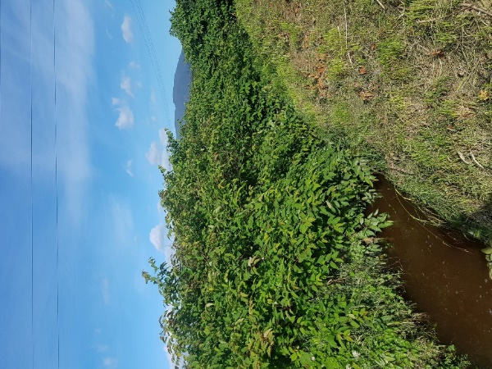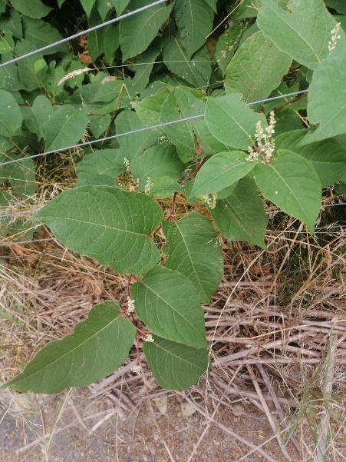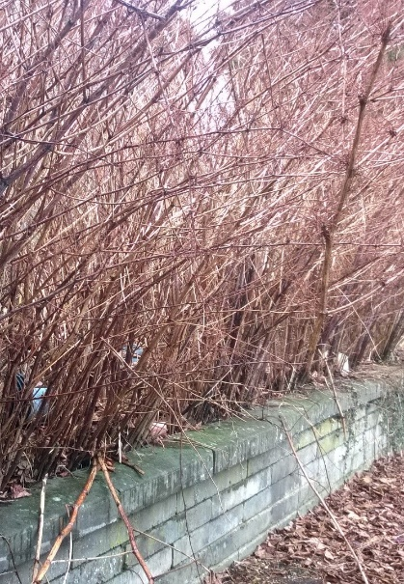

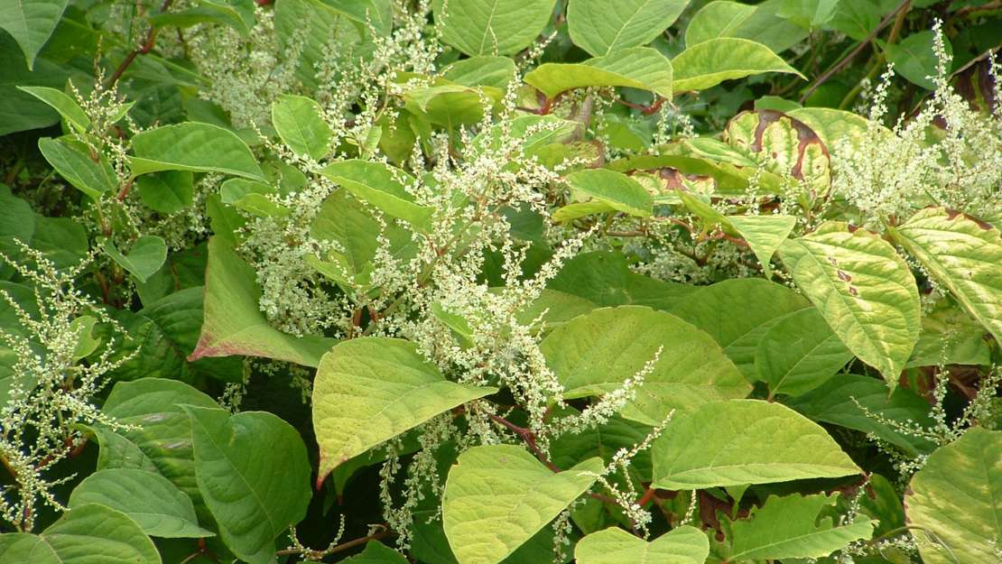

For more information or to report a sighting, contact the Tasman District Council Biosecurity team; Biosecurity@tasman.govt.nz 03 5438460

